As we look at the stories of Jesus in the Gospels we are beholding the Father. Jesus said to Philip, “If you have seen me you have seen the Father.” John 14:9. There is an important story in the Gospels that highlights an aspect of the character of our Father that is often completely misunderstood. Jesus spent almost His entire ministry within the territories of the Jewish nation. On this rare occasion the Saviour chose to travel into the pagan region of Phoenicia.

The deep seated pride and prejudice of the Jews held the hearts of the disciples and blinded their eyes to their participation in the national sin of racism and spiritual bigotry. Israel was called to be a light to the Gentiles; however, they turned this privilege to darkness through their disdain of their disadvantaged neighbours.

A woman living in this region, along with many in her community, had heard of this Jewish teacher who could heal people. Her daughter was “vexed with a devil” and she had vainly sought her gods to help her daughter but to no avail. She wondered if this Jewish teacher could help her. She determined to plead her case with Jesus while holding doubts as to what this Jew could, or would, do for her. The heartfelt cry of this poor mother reached the ear of the Saviour.

Have mercy on me, O Lord, thou Son of David; my daughter is grievously vexed with a devil. Matthew 15:22

As the self-sacrificing Son of God, His heart was full of compassion. He had come especially to this region to help her, yet what Jesus does next reveals something very important about the character of God.

But he answered her not a word. Matthew 15:23

His reason for doing this is immediately apparent in the very next sentence.

And his disciples came and besought him, saying, Send her away; for she crieth after us. Matthew 15:23

If Jesus had immediately granted her request, the hardness of the disciples would not have been revealed. Therefore the Saviour remained silent to see how they would respond. They interpreted His silence as a confirmation of their own racial prejudice. At the same time His silence tested the doubts that this foreign woman had concerning this Jewish teacher. We see the actions of Jesus act as a mirror to reveal what is in the hearts of those around Him.

The disciples were resisting the call to carry their personal cross in the face of the world’s rejection of the Son of God. This blinded them to many things Jesus was trying to tell them. As they were hearers of the law in this respect it caused them to perceive Jesus in the following manner:
2
1

But be doers of the word, and not hearers only, deceiving yourselves. For if anyone is a hearer of the word and not a doer, he is like a man observing his natural face in a mirror; for he observes himself, goes away, and immediately forgets what kind of man he was. James 1:22-24

The disciples had responded to Christ’s call to the new kingdom, but their hearts were not submitted to the principles of self-denial, nor to the rejection of their beloved Messiah by their nation. This made them hearers of the law coming from the mouth of Jesus. When Jesus was silent towards the foreign woman they saw their own natural face in Him and interpreted His action as racial intolerance. They were projecting onto Him their own attitudes and desires which resulted in their asking Jesus in front of this poor woman to send her away. How crushing this must have been for the woman to hear them speak like this. Her anguish for her daughter must have welled up inside her as she turned to hear what Jesus would say.

But he answered and said, I am not sent but unto the lost sheep of the house of Israel. Matthew 15:24

This answer tested everyone to see whether they were truly listening. The Saviour was introduced by John the Baptist with these words:

Behold the Lamb of God, which taketh away the sin of the world. John 1:29

Jesus was the Saviour of the whole world, not only of the physical Jews. The term Israel is a reference to all those who would accept the gift of Salvation. As the apostle Paul later described it:

For he is not a Jew, which is one outwardly; neither is that circumcision, which is outward in the flesh: But he is a Jew, which is one inwardly; and circumcision is that of the heart, in the spirit, and not in the letter; whose praise is not of men, but of God. Romans 2:28-29

In coming to Jesus, this woman was responding to the call of the Spirit. She revealed that she was, indeed, of the house of Israel. Not the Israel of the flesh, but the Israel of the Spirit. The name Israel was given to Jacob for the overcoming faith he manifested in wrestling with the angel in his desperation. Now this woman would demonstrate that she, indeed, was a true Israelite overcomer.
3

Then came she and worshipped him, saying, Lord, help me. Matthew 15:25

The faith of the woman does not yield. She holds on in faith. The Saviour is eager to help her but the test is not yet over.

But he answered and said, It is not meet to take the children's bread, and to cast it to dogs. Matthew 15:26

Here the word but does not necessarily mean that He was countering her appeal. The Greek word de can also mean and in the form of a continuation of thought. Jesus was now asking her to decide if she truly was an Israelite. His statement is framed in such a way as to test the racial prejudice of the disciples as well as her own doubts about this Jewish teacher. The woman might have said, “Lord, I am one of your children and I believe that you will help me.” This is the highest answer she could have given. Yet her answer is amazing in that although she calls herself a dog, she still hangs on in faith.

And she said, Truth, Lord: yet the dogs eat of the crumbs which fall from their masters' table. Matthew 15:27

Even though she thought Jesus was calling her a dog she held on still believing that Jesus would help her, making her a true overcoming Israelite. This woman’s love for her daughter and her response to the drawing of the Spirit gave her the victory of faith.

Then Jesus answered and said unto her, O woman, great is thy faith: be it unto thee even as thou wilt. And her daughter was made whole from that very hour. Matthew 15:28

This answer rebuked the disciples. They were hearing the words of Jesus with their natural hearts and were projecting onto Him their racial prejudice. When Jesus answered the woman’s request they were shocked and their perception of Jesus was shattered. At this point they must either consider the actions of Jesus a mystery or begin to question their racial hatred.

Jesus has the title in Scripture of “the Wisdom of God.” 1 Corinthians 1:24. This wisdom that comes from His Father allows Him to interact with humanity and reveal what is in their hearts without direct confrontation, which would only produce resistance. Why didn’t Jesus just tell them, “You have a racial hatred problem and you need to get over it”? This would have achieved nothing. Instead
Jesus speaks in a way that allows His words to act like a mirror and reveal what is in the heart.

Once you understand this principle, you can read the Scripture as a doer of the law and not simply a hearer beholding your own natural face. The test that Jesus gave to the disciples faces every reader of the Bible. Things are expressed in Scripture to reveal what is in the heart of the reader. As the disciples read into the actions of Jesus their own racial prejudice, many read Scriptures describing God through natural human under-standing rather than according to God’s true character. The following text sounds like God is forgetting about His people and turning His back on them.

I will scatter them as with an east wind before the enemy; I will shew them the back, and not the face, in the day of their calamity. Jeremiah 18:17

We use the term turning our back on people to indicate our rejection of them. Notice the context of how God turns His back in this text found in Exodus 33:22-23:

And it shall come to pass, while my glory passeth by, that I will put thee in a clift of the rock, and will cover thee with my hand while I pass by: And I will take away mine hand, and thou shalt see my back parts: but my face shall not be seen.

In this context God shows His back to shield Moses from the complete glory of His character. The love of God for His children is so great, so selfless and caring that when a sinner fully sees this love, it instantly brings a crushing sense of self-condemnation and guilt. Israel had forgotten the Lord and turned into other paths. The Lord hid His glory and turned His back so they would not be completely destroyed. He also turned His back that they might not see His suffering and grief at seeing His children reap what they had sown. “I gave my back to the smiters…” (Isaiah 50:6).

The actions of Israel were hurting our Saviour. Their idolatry hurt Him greatly. “In all their affliction He was afflicted and He carried them and bare them all the days of old.” Isaiah 63:9. So He gave His back to their smiting. This phrase can be understood as the Lord being wounded for the transgressions of His people in their rejection of Him and also the shielding of His people from the full glory of His character so they would not be fully crushed by their guilt. The natural heart will read the text as God simply rejecting His people because that is exactly how a human being would naturally react and when we read the Bible naturally that is what we understand. Thankfully God’s thoughts are not our thoughts. Isaiah 55:8-9.

4

Did Jesus Call
This Woman
A Dog?

“It isn’t right to take from the children and throw it to the dogs.” ~ Matthew 15:26 ~
When we read the Bible, Jesus touches us with His gentleness, meekness, and kindness. But there was one time when a woman came to Him and asked for Him to heal her daughter, and, in contrast to other times when people asked for help, He says this:

It isn’t right to take from the children and throw it to the dogs. Matthew 15:26; NLT

This shocks us. Did Jesus just call this woman a dog?! The fact that this response from Jesus seems so unlike Him means that this story should be studied more deeply.

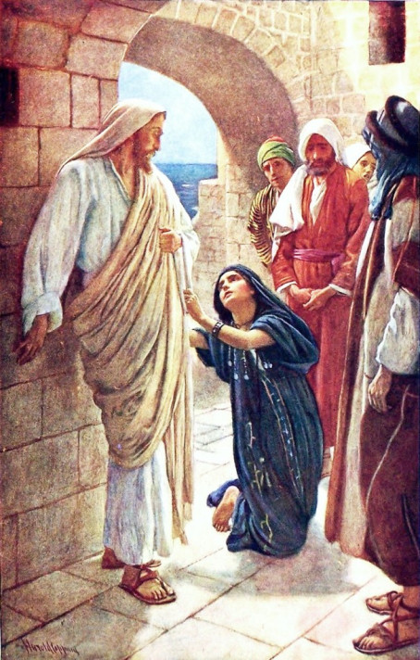

You’ve been reading an excerpt from the book:
Agape
A Revelation of the Father’s
Character of Love

Download the entire book for FREE at:

